Editing J2EE deployment descriptors
JBuilder has a Deployment Descriptor Editor, also known as the DD Editor, you can use to edit the deployment descriptors of various types of J2EE modules. This chapter introduces you to the DD Editor and gives you an overview of how to use it.
The DD Editor can edit these types of J2EE modules:
- Web - A Web module contains all the compiled source files, resources, and deployment descriptors needed to deploy a web application. You can create web modules using JBuilder's web wizards and tools. For complete information about web modules, see the Web Application Developer's Guide.
- EJB - An EJB module contains all the compiled source files, resources, and deployment descriptors needed to deploy one or more enterprise beans. You can create enterprise beans using JBuilder's EJB wizards and tools. For complete information about creating EJB modules and enterprise beans, see "Creating session and message-driven beans with the EJB Designer", " Creating EJB 1.x components with JBuilder", "Creating entity beans with the EJB Designer", and "Creating EJB 1.x entity beans from an existing database table." All these chapters are in the Developing Applications with Enterprise JavaBeans book.
- Application client - An application client module contains all the resources and deployment descriptors for a client application that references one or more enterprise beans. Create the module using the File|New|Enterprise|Application Client Module wizard. For more specific information about creating application client modules and editing the deployment descriptors, see "Creating an application client module" in the "Developing enterprise bean clients" chapter of Developing Applications with Enterprise JavaBeans.
- Connector - A connector module contains the resource adapter and deployment descriptors that connect the selected application server with an existing enterprise information system. Create a connector module using the File|New|Enterprise|Connector Module wizard. For more specific information about creating connector modules and editing the deployment descriptors, see "Integrating with Enterprise Information Systems."
- Application - An application module can contain any of the other types of J2EE modules and wraps them into a single application and includes its own deployment descriptor entries. Create an application module using the File|New|Enterprise|Application Module wizard. For more specific information about creating application modules and editing the deployment descriptors, see "Creating an application module" in the "Deploying enterprise beans" chapter of Developing Applications with Enterprise JavaBeans.

Displaying the DD Editor
After you have created a J2EE module, display the DD Editor by double clicking the new module in the project pane. If the module is an EJB module, you must then click the EJB DD Editor tab in the content pane of the browser. You'll also see nodes appear in the structure pane. As an example, here is how the browser appears when a EJB module has been double-clicked, the EJB DD Editor page in the content pane selected, and the BEA WebLogic Platform Server 8.x is the selected server for the project:
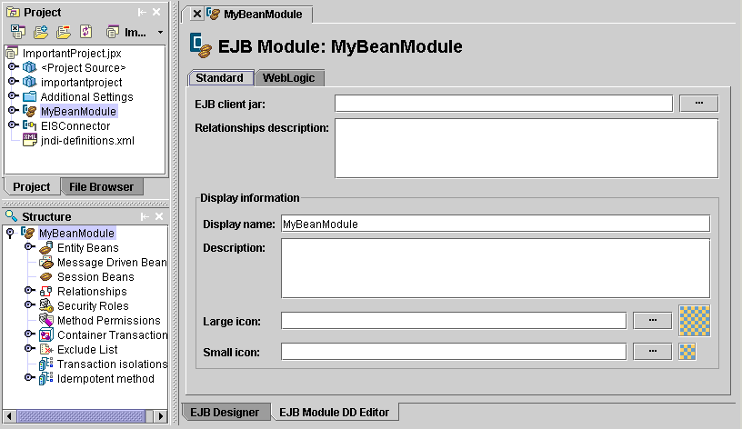
Some of the nodes in the structure pane are expandable as they contain data already. In this particular EJB module, two entity beans were created using the EJB Designer and added to the MyEJBModule module. As a result, the Entity Beans node is expandable. When this node is expanded, you can see the entity beans the module contains:
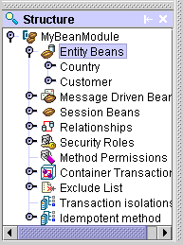

Standard and server-specific pages
Usually you will see a Standard page for each node in the structure pane that can be expanded. This Standard page contains fields that apply to all servers. Often you will also see one or more tabs that apply to a specific server. Click the server-specific tab to see the page. The pages available depend on which server you selected for the project. In this example, there are three additional pages available for a WebLogic entity bean as WebLogic is the selected server:
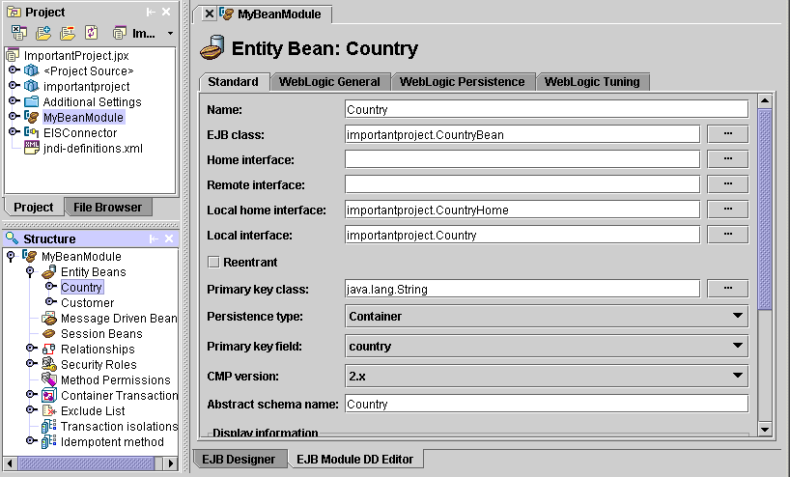
Tip: To see information about a page in the DD Editor, press F1.
Fill in each Standard page with the information requested. You can find more specific information about filling in these fields in other parts of the documentation that discuss the various types of J2EE modules:
- EJB modules
- Web modules
- Application client modules
- Connector modules
- Application modules
Click any server-specific tabs and fill in each of these pages also. Whether there are server-specific pages available depends on the type of node you are editing and on your selected server. Here you can see a WebLogic-specific page selected for an EJB module:
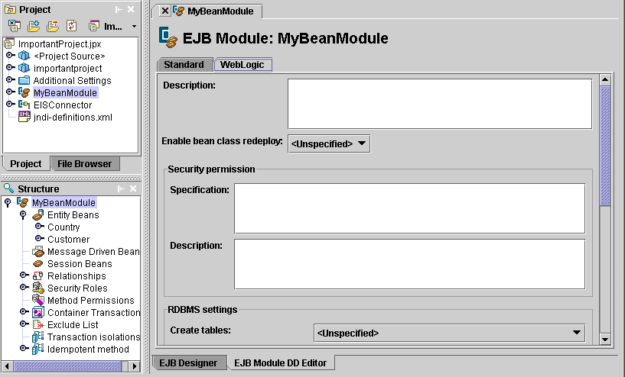
You may have noticed already the nodes in the structure pane that are marked with the server-specific icon (). These too are specific to a particular server. In this particular case, that server is BEA WebLogic Server.

Adding to and deleting from a deployment descriptor
To add descriptor information to a module,
- Right-click the type of node for which you want to add information to the descriptor in the structure pane and choose Add.
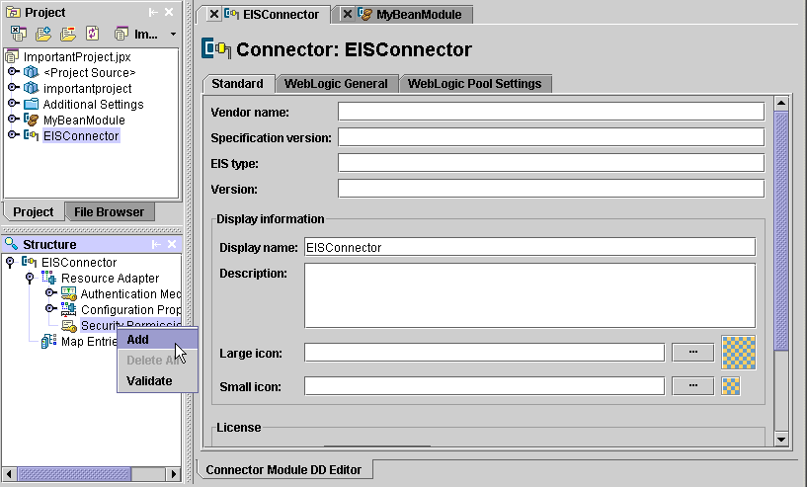
A new page appears in the content pane that corresponds to the type of node you selected. The sample image shows a security permission being added to a connector module.
- Fill in the information requested on this page and new node for that page appears under the node you selected in the structure pane.
Double-clicking a top-level category node, such as Entity Beans in an EJB module, displays a page with a table containing all existing entries of that type. For example, if an EJB module contains two entity beans, double-clicking the Entity Beans node displays a table containing an entry for each entity bean. You can also use this page to add and delete entries or reorder the list with the Move Up and Move Down buttons.
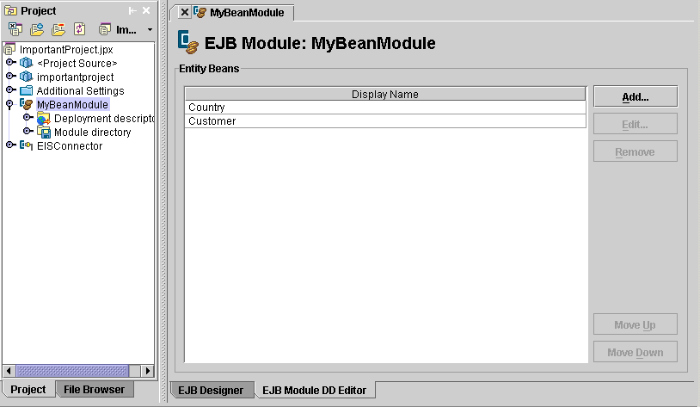
To add an entry, click the Add button, then select the new entry in the table and double-click it. The appropriate page appears. Fill in the required information.
There are two ways to delete an entry from a category:
- Right-click the node you want to delete in the structure pane and choose Delete.
- Double-click the top-level category node. On the page that appears, select the entry from the table you want to delete and click the page's Remove button.

Validating a deployment descriptor entry
You can help ensure the deployment descriptor information that is common to all servers is entered correctly by using the DD Editor's validator. The validator checks that the deployment descriptor conforms to the DTD specification and also makes other checks such as insuring proper naming conventions are used.
To validate a deployment descriptor,
- Right-click the node in the structure pane you want to validate.
- Choose Validate on the context menu that appears.
Note: Server-specific data is not checked. Only data found on Standard pages is validated.
If errors exist, they will appear on a Validation page in the message pane:
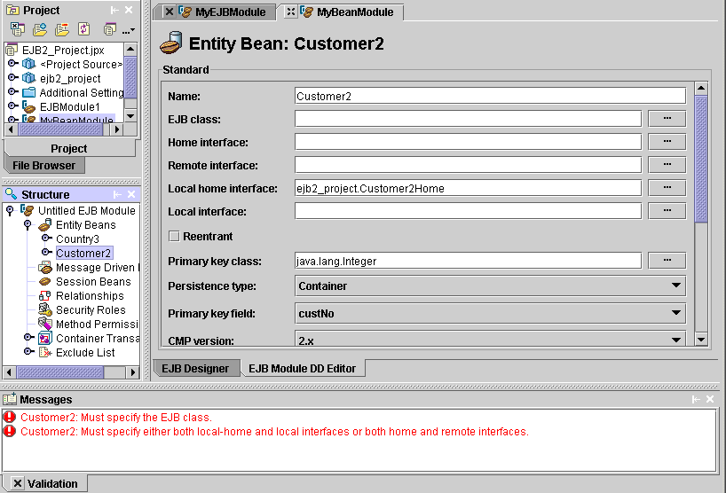
Click an error message and the page on which the error occurs appears in the DD Editor.

